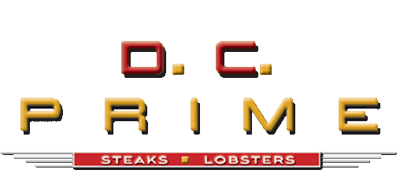
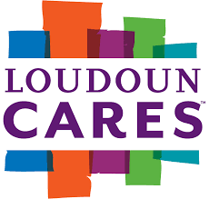
2022 Sponsorship Levels

Title Sponsor / $10,000
- Welcome Event Banner with Company Logo
- Exclusive 1st Hole Sponsorship Signage
- Special Recognition in all Public Relations / Social Media
- Opportunity to Include information/swag in all Player Welcome Bags
- 3 Foursomes (12 golfers)

Banner Sponsor / $5,000
- Exclusive 18th Hole Sponsorship
- Company logo on Welcome and event Banners
- Opportunity to Include information/swag in all Player Welcome Bags
- Recognition on Social Media
- 2 Foursomes (8 golfers)

Memento Sponsor / $3,000
- Sponsor Name / Logo Imprinted on Main Memento Along with Tournament Logo
- Exclusive Hole Signage (Signature Hole)
- 1 Foursome (4 golfers)

Golf Ball Sponsor / $2,500
- Sponsor Name / Logo Imprinted on Golf Balls Presented to all Participants
- 1 Foursome (4 golfers)

Hole-In-One Sponsor / $2,500
- Exclusive Signage at the Hole-in-One Contest
- Opportunity to Include information/swag in all Player Welcome Bags
- 1 Foursome (4 golfers)

Cannon Sponsor / $2,500
- Exclusive signage and table at Cannon hole (Hole #3 – Signature Hole)
- Include information/swag in all Player Welcome Bags
- 1 Foursome (4 golfers)

Beverage Cart – Drink Sponsor / $2,000
- Signage at Drink Station before event and on all Beverage Carts
- Signage and Recognition at Banquet
- 1 Foursome (4 golfers)

Prime Sponsor / $1,500
- Tee and Green Signage at exclusive hole
- Keepsake Embroidered Golf Flag to be displayed at hole
- Opportunity to Include information/swag in all Player Welcome Bags
- 1 Foursome (4 golfers)

Golf Hole Sponsor / $1,000
- Tee and Green Signage at designated hole
- Opportunity to Include information/swag in all Player Welcome Bags
- 1 Foursome (4 golfers)

Golf Foursome / $750
- 18 Holes of Golf for 4 Players
- Event Mementos & Player Welcome Bags

Individual Golfer / $195
- 18 Holes of Golf for 1 Player
- Event Mementos & Player Welcome Bags

Course Sponsor / $250
- Signage on the course

